
Mrs Eagleton

Hello Reception class!
In Reception we work as a team with lots of adults to help you. My name is Mrs Eagleton and I will be your teacher in September.
Here are something of the things I like to do.
Mrs Eagleton’s favourite colour is yellow.
 | 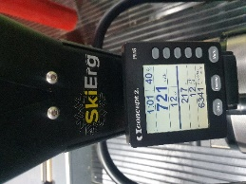 | 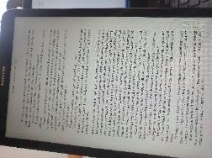
I love going to the beach and on sunny holidays | I love going to the gym and doing exercises. | I love reading books.

We have lots of exciting things planned for when you join us in September. We have an exciting classroom with so many fun areas for you to explore. We cannot wait to get to know you and meet your grownups. What an exciting time it will be for everyone!

Maybe you could draw me a picture about the things you like to bring with you on your first day at school?

