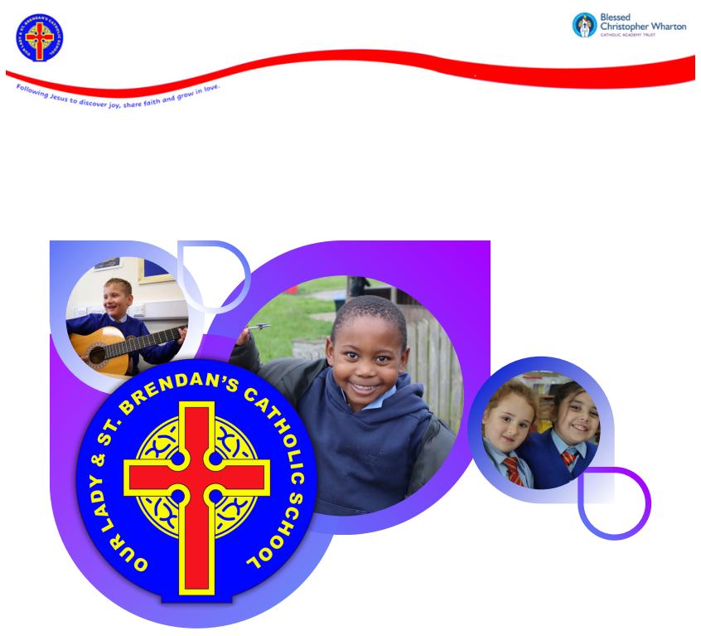

Our Lady and St Brendan’s Catholic Primary School
Behaviour Policy and Statement 2025–2026
Approved by: Academy Council – September 2025
Next Review: September 2026

Contents
- Introduction
- Core Virtues
- Vision, Mission and Aims
- Encouraging Good Behaviour and Visible Consistencies
- Rewards
- Rights and Responsibilities
- Policy Aims
- Expectations
- Responsibilities
Pupils
Staff
Parents/Carers
Headteacher and SLT
- Modelling by All Adults
- Recognised Inappropriate Behaviour
- Sanctions – A Stepped Approach
- Conflict Resolution – 3 Steps
- Day-to-Day Procedures
- Monitoring and Recording
- Partnership with Parents, Carers and Families
- Summary from the Behaviour and Attitudes Leader

1. Introduction
At Our Lady and St. Brendan’s Catholic Primary School, we believe that every child is created in the image of God and is called to flourish in joy, faith and love. Our approach to behaviour is rooted in Gospel values, which remind us that relationships should be based on dignity, respect, forgiveness and reconciliation.
This policy also reflects our statutory and moral responsibilities. We are committed to:
- British Values: democracy, the rule of law, individual liberty, mutual respect and tolerance.
- The Equality Act 2010: ensuring no child or adult is discriminated against because of protected characteristics.
- The UN Convention on the Rights of the Child (UNCRC): recognising children’s universal rights to safety, education and participation.
By linking Catholic ethos, British Values, equalities law and children’s rights, we provide a framework where all members of our community feel valued, safe and able to achieve.

2. Core Virtues
Joy
Faith
Love
3. Vision, Mission and Aims
Vision: To strive for excellence in the discovery of joy in learning. With Christ at the centre, we will share our faith together and grow in love as we journey beyond the familiar and into the unknown.
Mission: Following Jesus to discover joy, share faith and grow in love.
Aims:
- To grow closer to God through high-quality Prayer && Liturgy, Religious Education, and Catholic Social Teaching.
- To nurture pupils to flourish and achieve their academic potential.
- To work in partnership with families and the parish to create a welcoming learning community.
4. Encouraging Good Behaviour and Visible Consistencies
Research shows that consistent adult behaviour, positive reinforcement and high expectations have the strongest impact on school culture (EEF, 2019; Ofsted, 2021). At OLSB, we embed this within our Catholic mission.
Staff practices:
- Staff greet and welcome children daily at the point of entry.
- Every child is made to feel valued and that they belong.
- Clear expectations are taught through the Virtues curriculum.
- Staff use praise and reinforcement of the best conduct.
- Shouting or whistles are avoided; staff use calm, consistent language.
- Children are corrected with joy, faith and love, never labelled as “naughty.”
- Praise is public; reminders are private.
- Achievements are celebrated visibly and regularly.
- Respect and responsibility are promoted in every interaction.
Pupils are encouraged to:
- Act with justice and fairness.
- Be playful and joyful, embracing challenge safely.
- Begin each lesson with a fresh start, knowing forgiveness and reconciliation are part of our community.
5. Rewards
Praise and reward are central to our approach. Children achieve more when successes are recognised (EEF, 2019). At OLSB, rewards are rooted in our virtues and vision: discover joy, share faith, grow in love.
Systems include:
- Virtue Heroes awarded weekly.
- Class Dojos with Bronze, Silver, Gold thresholds:
- Class Dojo Points accumulate over the course of the academic year with children receiving the following certificates during Friday's celebration assembly:
Bronze
Silver
Gold
Points are given by any member of staff for good behaviour, groups or individuals may be
awarded points.

- Headteacher’s Awards at the end of each half term.
- Walls of Fame in classrooms.
- OPAL Gold Membership- Exclusive use of equipment of choice for good playtime behaviour.
- Positive communication home.
- Star of the Week Celebration Assembly every Friday.
- Class-specific awards.
- Stickers from SLT.
- Attendance incentives (bronze, silver, gold pin badges).
- Leadership responsibilities (Head Pupils, Mini Vinnies, etc.).
6. Rights and Responsibilities
At OLSB, our Gospel values underpin our understanding that all are made in the image of God. These rights and responsibilities are also grounded in British Values, the Equality Act and the UNCRC.
Right to be valued → Responsibility to value others.
Right to be safe → Responsibility to keep self and others safe.
Right to achieve → Responsibility to allow others to work and achieve.
7. Policy Aims
Promote a calm, purposeful and joyful atmosphere for learning.
Foster caring attitudes where achievements at all levels are valued.
Encourage independence, self-discipline and responsibility.
Ensure consistency of approach with parental cooperation.
Set clear boundaries of acceptable behaviour for safety and learning.
Develop a shared sense of purpose among pupils, staff and parents.
8. Expectations
Show self-discipline and independence, with or without supervision.
Speak politely and respectfully.
Listen attentively.
Apply focused effort in lessons.
Show good manners, courtesy, co-operation, and respect for others.
Move safely and quietly around school.
Play safely and care for the environment.
9. Responsibilities
Pupils
- Work to the best of their ability and allow others to do the same.
- Treat others with respect and kindness.
- Follow instructions from staff.
- Care for property and the environment.
- Wear correct uniform (including tie and leadership pin badge, if applicable).
- Co-operate with peers and adults.
Staff
- Treat all pupils fairly and with respect.
- Raise pupils’ self-esteem and nurture potential.
- Provide a safe, engaging and inclusive curriculum.
- Be consistent, clear and fair in expectations.
- Model positive behaviour in line with our values.
- Work in partnership with parents.
- Recognise pupils’ individual needs and make reasonable adjustments.
Parents/Carers
- Support the school in teaching appropriate behaviour.
- Encourage independence and self-discipline.
- Show interest in their child’s school life.
- Maintain positive relationships with school staff and adhere to the Parental Conduct Policy.
Headteacher and SLT
- Be visible and present around school.
- Celebrate staff and pupils who regularly go above and beyond.
- Model positivity and promote a culture of joy, faith and love.
- Ensure staff training needs are identified and met.
- Use behaviour records to analyse trends and target support.
- Support staff in applying the staged approach and in daily encounters.
10. Modelling by All Adults
All adults must model the behaviours we wish to see.
Expectations include:
- Calmness and consistency.
- Respectful communication.
- Visible kindness.
- Fairness and justice.
- Restorative example.
- Presence and visibility.
“The greatest among you must be your servant” (Matthew 23:11).
11. Recognised Inappropriate Behaviour
Examples include (not exhaustive):
- Bullying, racial or homophobic abuse.
- Refusal to follow instructions, rudeness, swearing.
- Play fighting, physical aggression, spitting.
- Damage to property, misuse of equipment.
- Name-calling, deliberate provocation.
- Leaving school grounds without permission.
- Online abuse or inappropriate use of technology.
12. Sanctions – A Stepped Approach
Sanctions are: fair, calm, consistent, predictable, restorative, Gospel-rooted.
- Each stage is clear to support all children, staff and stakeholders. For each stage the adult delivering the sanctions is trained to ensure that there is a dialogue around each incident that has led to the next step. This ensures that the child understands what would result in the next step creating a consistent and clear process.
- In EYFS and KS1 the system is still applied but where a restorative conversation can result in the child given the opportunity to fix their behaviour. This is displayed in the classroom so all can see success.
- An instant removal from any communal area for any form of assault.
Step 1 – Class Teacher/TA: verbal reminder ‘Warning’ to change unacceptable behaviour.
If unacceptable behaviour continues after a warning, a yellow card is given.
Step 2 – Class Teacher: Yellow Card – final warning that a red card will be given if behaviour doesn’t improve. (Romans 13:1).
If unacceptable behaviour continues a red card is given.
Step 3 – Key Stage Leader: Red Card – lost playtime and lunch time – 1 day (2 Cor 13:5).
The child is sent to the Key Stage Leader with the red card for morning and lunchtime detentions and restorative practice. Parental contact by Key Stage Leader.
Step 4 – DHT (Behaviour Leader): Red Card 2 - 2nd red card in 10 days– if a child receives 2 red cards within a period of 10 days, the child is removed from the class and any unfinished work is to be completed during breaktime or lunchtime. Parental contact by DHT/Behaviour Leader (John 21:15–19).
Step 5 – DHT (Behaviour Leader): Any child who receives a Red Card 2 in step 4 must undertake a behaviour support programme with a member of the Pastoral Team (Luke 24:13–35). If a further red card is received during the therapeutic programme, the child moves to step 6.
Step 6 – DHT (Behaviour Leader): Behaviour Contract and Internal Exclusion (John 8:11).
The child will be isolated in school if the inappropriate behaviour persists. Parental meeting with Behaviour Leader to discuss behaviour choices and strategies to work together at home. Behaviour contract signed by parents, child and school with a warning of a fixed term exclusion if contract is broken.
Step 7 – Headteacher Fixed Term Exclusion (Luke 15:4–7)
If a child breaks the terms of the behaviour contract or displays any of the following serious behaviours;
- Physical assault causing bodily harm to a child. Eg punching, kicking, headbutting or strangling.
- Physical assault on staff eg. Hitting, kicking, throwing objects at or threatening to hurt.
- Dangerous physical outbursts that risk serious harm to others.
The Headteacher retains the right to determine the length of the fixed term exclusion in accordance with the severity of the incident.
Step 8 – Headteacher & Academy Council: Permanent Exclusion (Romans 12:18).
If the child continues to persistently display the inappropriate behaviours following the pastoral support and parental meeting, a permanent exclusion will be considered at the discretion of the Headteacher.
An appeal can be made by parents in accordance with the Trust Complaints Procedure.
13. Conflict Resolution – 3 Steps
All adults in school will conduct the following restorative practice following a behaviour incident;
1. Each child explains in turn, what happened. how they felt, how it can be resolved.
2. Adult to establish a full account of the incident using - Appendix 1 – Blank Level Behaviour Prompts. This conversation will be free from interruptions with respectful listening and eye contact.
3. Adult ensures fairness and reconciliation by ensuring the child says sorry with an ‘I forgive you’ reply.
14. Day-to-Day Procedures
Arrival: 8:30am doors open; staff welcome children into school and discuss feelings on the check in boards.
Playtime: children play within boundaries; staff engage with children (OPAL).
Movement inside school: walk calmly and quietly.
Corridors: kept tidy; not play areas.
Assemblies: enter silently, listen carefully
Liturgies: enter silently, engage prayerfully.
Departure: 3:00pm collection.
Y5/6 may walk home alone with consent.
Phones handed in and stored securely until end of day.
15. Monitoring and Recording
CPOMS used for incidents, red cards, serious events, restorative conversations. All red cards reported and parents informed before child leaves school.
Records reviewed termly to target support, interventions, referrals.
16. Partnership with Parents, Carers and Families
OLSB is a beacon of joy, faith and love for the whole community.
Parents, carers and families are expected to adhere to the Parental Conduct Policy:
- Treat staff, pupils and others with respect, dignity and courtesy.
- Model positivity and calmness.
- Support the school’s ethos, policies and staff.
Where expectations are not met, the school may:
- Issue a written reminder of expectations.
- Restrict or ban access to the site.
- Report incidents to relevant authorities.
“Encourage one another and build each other up” (1 Thess 5:11).
17. Summary from the Behaviour and Attitudes Leader
“At OLSB, behaviour is not seen as a barrier but as a learning opportunity. Drawing on Paul Dix’s work, I emphasise consistency, visible kindness, and clear boundaries. Every child deserves the dignity of being corrected calmly, given certainty in routines, and offered reconciliation when mistakes are made. Our focus is always on repairing relationships, not breaking them further.
This restorative approach is firmly rooted in Catholic Gospel teaching: we are called to forgive ‘seventy times seven’ (Matthew 18:22), to love one another as Christ loves us (John 13:34), and to recognise the dignity of every person as a child of God. In practice, this means we challenge behaviour while affirming the worth of the child, guiding them towards reconciliation, forgiveness and growth.”
C. Spillane
Deputy Headteacher, Behaviour and Attitudes Leader
Appendix 1 – Blank Level Behaviour Prompts for Restorative Practice
Blank Level 1 – Introduction and basic recount; Questions relate to immediate impressions and recollection. This draws solely on short term memory and concrete thinking.

- What has happened?  - Where did it happen?  - What did (NAME) do?  - What part of your body is hurting? | - When did it happen?  - Who was there?  - What did (NAME) say?
Blank Level 2 – Refinement: Questions that involve some selective analysis such as describing, distinguishing and sequencing. This starts to move the young person from concrete to higher order empathetic thinking.

- What happened first?  - What happened next?  - What happened then?  - What happened after (STATE SPECIFIC PART OF INCIDENT)  - Where were you when (STATE SPECIFIC PART OF INCIDENT) | - Where did you go after (STATE SPECIFIC PART OF INCIDENT)  - What does the person look like?  - Where was (NAME) when (STATE SPECIFIC PART OF INCIDENT) happened?  - What does your (HURT PART OF BODY) feel like?
Blank Level 3 – Empathy and Foresight; Requires the young person to make basic predictions, assume the role of another. This adds sequential thinking to empathetic thinking.
- How do you feel inside?  - How might (NAME) feel inside?  - How did (NAME) try to help?  - What does (WORD/PHRASE) mean?  - What sanction/consequence usually follows (INCIDENT)? | - What might happen next?  - What are you going to do next? (Apologise)  - What are you going to say next? (Sorry)  - What might (NAME) do next?  - What might (NAME) say? (I forgive you)
Blank Level 4 – Problem solving; Focusses primarily on causation and working out solutions. This draws on high order thinking skills now adding thinking sequentially about adding precursors and consequences.
- Why did you (STATE AN ACTION)?  - Why do you think (NAME) keeps/did (VERBAL PHRASE FROM INIDENT i.e.hitting/ kicked you) ?  - What could you do to make it better?  - What could (NAME) do to make it better?  - How do you know when someone is feeling (EMOTION)?  - How do you think it feels to be (EMOTION)?  - If you were (NAME) what would you do? | - How could you avoid it happening again?  - What could you say to help stop it happening again?  - Where could you go to calm down?  - What could you do to calm down?  - How could (ADULT) help you stop it from happening again?  - What might you say to (ADULT) to show you needed help?

At the end of the restoration, ensure that the child takes ownership of their mistake and can admit the poor choice. Ask the child ‘What does sorry mean?’ They need to understand that it is their promise that it won’t happen again.
Ensure that they understand that the matter has been dealt with and ask them to tell you what they will say to their parent. This will determine if they understand that it has been dealt with thoroughly and that they have learned from the process through the remorse shown in their answers.

